Activity 1: Change the following paragraph into a set of instructions, using imperatives (05)
Process of Producing Bottled Fruit Juice:
Fresh fruits are first delivered to the factory and inspected carefully to ensure quality. Any damaged or unripe fruits are removed during the sorting process. The selected fruits are then washed thoroughly with clean water to remove dirt, pesticides, and other impurities. After washing, the fruits are peeled and cut into smaller pieces by machines. The pieces are crushed and pressed to extract the juice. The extracted juice is filtered to remove seeds, pulp residue, and other solid particles. It is then pasteurized by heating it to a specific temperature to kill harmful bacteria and extend shelf life. After pasteurization, the juice is cooled quickly to preserve its flavor and nutritional value. Meanwhile, empty bottles are sterilized using hot water or steam to ensure hygiene. The prepared juice is poured into the sterilized bottles through automated filling machines. The bottles are sealed tightly with caps to prevent contamination. Finally, labels are attached to the bottles, and they are packed into cartons for storage and distribution to markets.
Example:
• Deliver the fresh fruits to the factory and inspect them carefully to ensure quality.
Activity 2: Read the chart below to learn about e-learning and classroom learning. Then write a comparative paragraph using comparative expressions. Please include which mode of learning you would recommend. 5
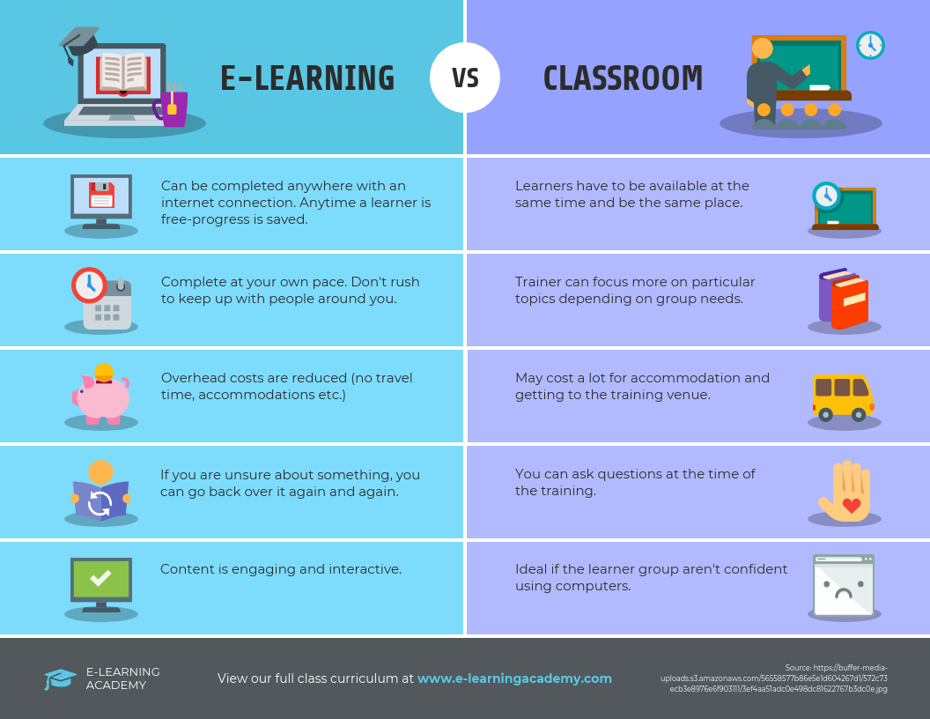

Sample Answer:
Activity 1:
Process of Producing Bottled Fruit Juice:
• Deliver the fresh fruits to the factory and inspect them carefully to ensure quality.
• Remove any damaged or unripe fruits during the sorting process.
• Wash the selected fruits thoroughly with clean water to eliminate dirt, pesticides, and other impurities.
• Peel the fruits and cut them into smaller pieces using machines.
• Crush and press the fruit pieces to extract the juice.
• Filter the extracted juice to remove seeds, pulp residue, and other solid particles.
• Pasteurize the juice by heating it to a specific temperature to destroy harmful bacteria and extend shelf life.
• Cool the juice quickly after pasteurization to preserve its flavor and nutritional value.
• Sterilize the empty bottles with hot water or steam to ensure proper hygiene.
• Pour the prepared juice into the sterilized bottles using automated filling machines.
• Seal the bottles tightly with caps to prevent contamination.
• Attach labels to the bottles and pack them into cartons for storage and distribution to markets.

Activity 2:
E-learning is more flexible than classroom learning because it can be completed anywhere with an internet connection, whereas classroom learning requires students to be present at the same time and place. Online study is more convenient since learners can progress at their own pace, while classroom learners must follow a fixed schedule. In addition, e-learning is usually less expensive because it reduces travel and accommodation costs, whereas classroom learning may be more costly for these reasons. Another advantage is that online learners can review lessons more easily and repeatedly, while classroom students have fewer opportunities to revisit the same explanation. However, classroom learning is more immediate in terms of interaction, as students can ask questions directly during the session. Overall, e-learning appears more flexible and cost-effective than traditional classroom learning. Therefore, e-learning is recommended as it is more adaptable to individual needs and lifestyles.

